**Tableau**

Course-End Project Problem Statement



**Course-End Project: Sales Analysis**

**Problem Statement:**

DigiComp is a global enterprise that, among other things, caters to designing, developing, manufacturing and marketing products like - clothing materials.

DigiComp has expanded its presence across the globe, and the business wants to get an in-depth analysis of its sales so as to make better sales decisions. So, DigiComp has decided to use Tableau Dashboards to consolidate the data from multiple sources, and carry out the sales analysis. This will help the sales department to access the data from remote locations that would increase the overall timeliness, find inefficiencies, and make better decisions.

As a Tableau developer, you are tasked with creating an interactive Sales Dashboard in Tableau for the Sales department to use it for ad-hoc analysis and reporting.

**Description of the Datasets:**

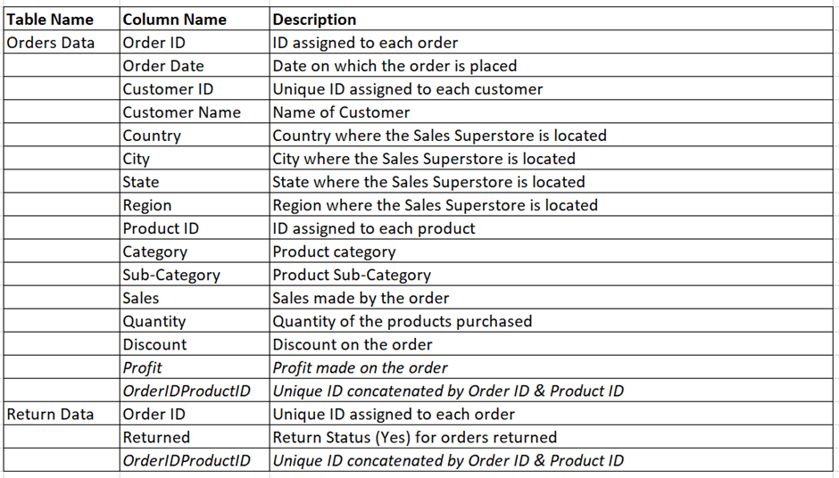

**Perform Data Visualization:**

Perform the following using charts and visuals:

*\*Note: The italicized words indicate the actual columns in the dataset.*

1. Analyse the *Sales/Profit* for all the months of 2017 as a continuous line chart and area chart.
2. Show *Category-*wise *Sales* as Packed Bubbles Chart suggesting categories with highest to lowest sales.
3. Create a Treemap chart showing *Sales* by *Category* and *Sub-Category*.
4. Visualize *Sales* vs *Profit* on a Scatter Plot with *Category* and *Sub-Category* breakdown.
5. Compute aggregated values for all Sales KPIs like *Total Sales, Profit, Profit Ratio, Discount* in a Table view.
6. Analyse the *Sales* for all the quarters of all the years across *State*, and *Category* as a Highlight Table. Highlight the columns by Profit.
7. Connect to the ***Return Data*** dataset, and blend it with ***Orders*** data to compute the *number of orders returned* for each Product *Category* in 2016.
8. Show *Sales/Quantity* of Product *Category* in each *Region* as a Stacked Bar Chart.
9. Determine the top 5 *products* and top 5 *customers* by *Sales*, i.e., *Products* and *Customers* that are generating the highest revenue as a bar chart.
10. Visualize *Sales* by *State* where the sales variation is highlighted by color as a Map Chart.
11. Visualize Sales & *Profit* analysis by *Customer* on a Scatter Plot.
12. Represent the *Number of orders* received by *Quantity* bins as a Histogram.
    1. Create Quantity bins.
    2. Use Measure Count of Quantity as calculation.
    3. Drag Count of Quantity in Row Shelf and Quantity bins in column shelf
13. Create an interactive fixed size floating layout Dashboard that can be shared with the leaders using the above analysis.
14. Create a story with the following visuals:

*\*Note: The below-listed visuals are done as part of tasks 1 to 6.*

* 1. *Sales/Profit* for all the months of 2017
  2. Category-wise *Sales*
  3. *Sales* by *Category* and Sub-Category.
  4. *Sales* vs *Profit*
  5. Aggregated values for all *Sales* KPIs and
  6. Sales for all the quarters for all the years across *State*, and *Category*.

